**Adding a Facility to Program Office**

Ensure you are in the proper program office, then choose “Facilities” in the Environmental Health menu on the left.

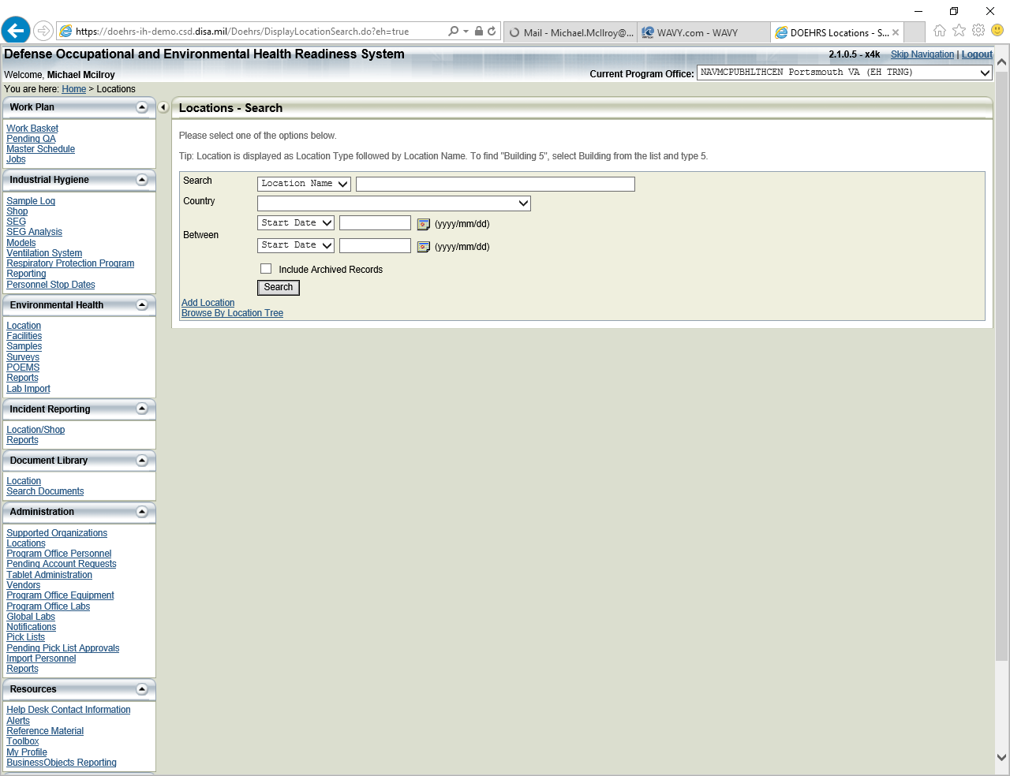

Choose Add Facility

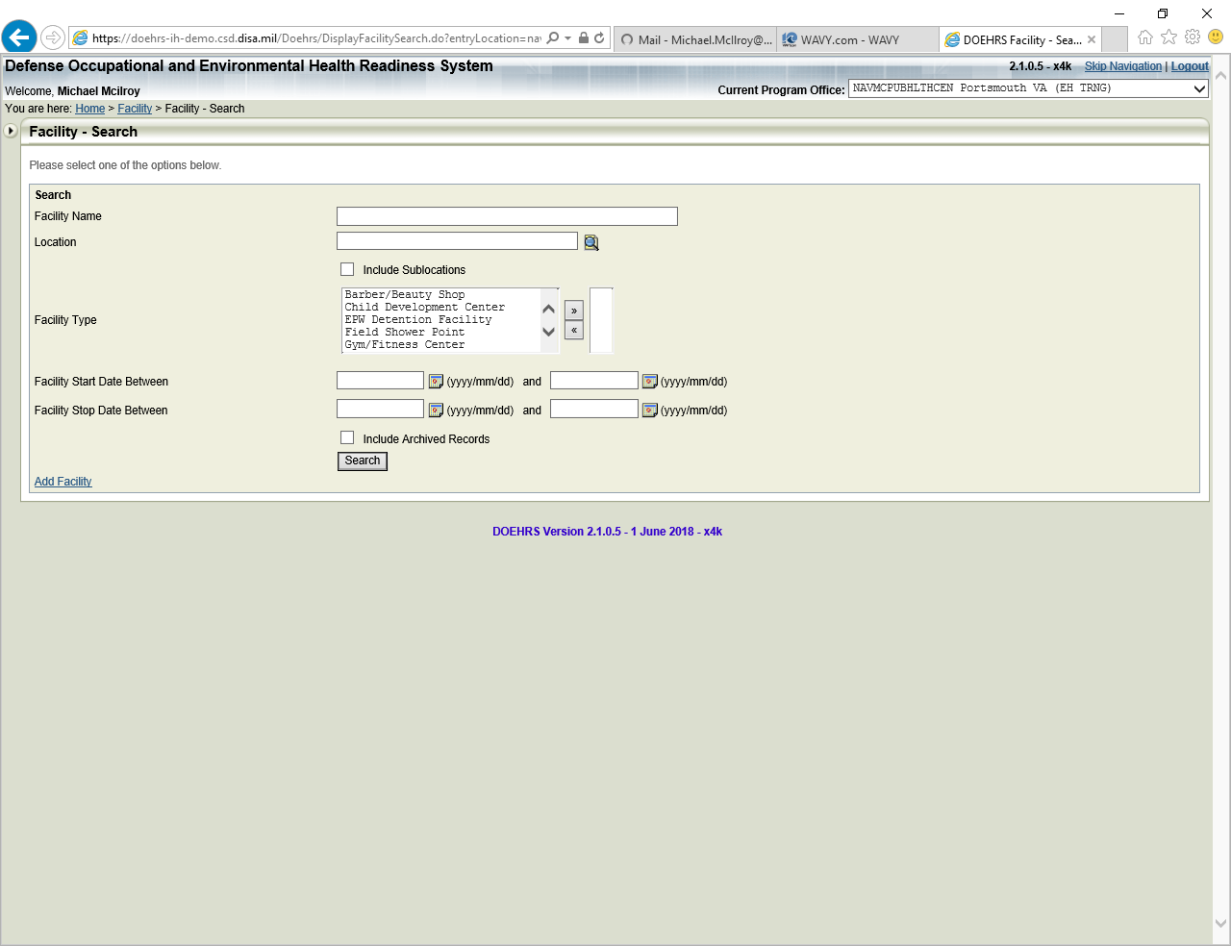

Choose your Parent Location using the icon. Then choose facility type to be added and click continue.

**\*\*Reminder\*\*** Do not add Child Development Center, survey currently not in DOEHRS.

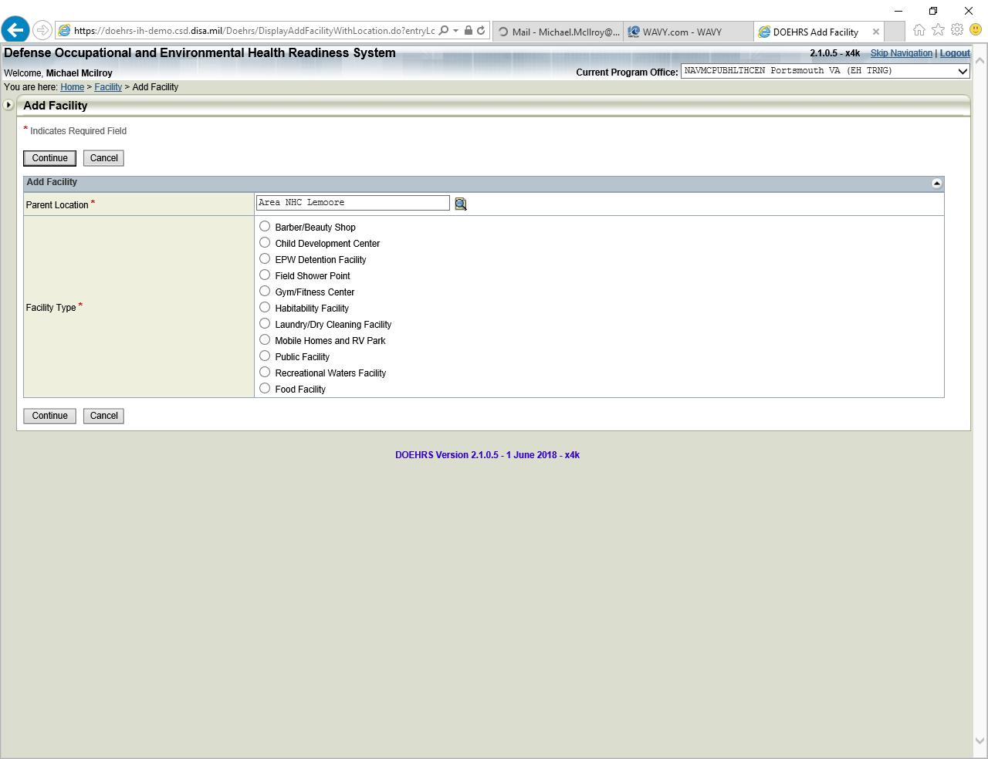

Add facility name, complete address, city, state, zip code.

You **do not** need to add coordinates.

Click “Save” when all areas have been completed.

Repeat the process for other facilities.

